1

Crack detection using simple edge detection technique

Vaishnav Kumar S

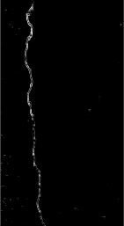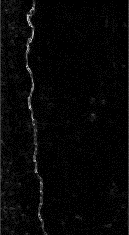**Abstract**

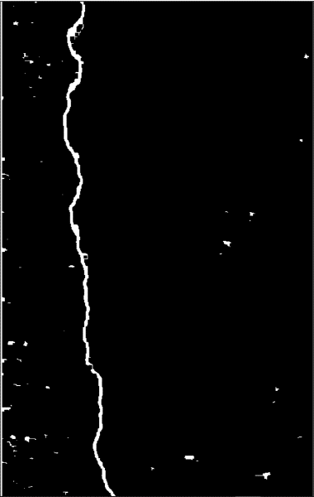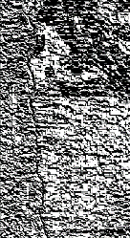**cracks are a major concern in the construction as they affect the durability and reliability of structures, so the task of constant monitoring for cracks plays a crucial role in ensuring structural health thereby by safety. The manual process of checking for cracks is laborious and is prone to human miss. By using Image processing techniques to extract the crack specific information from a raw input like width, depth, and length of the crack can help to speed the process of crack detection and understand the nature of the aberration. In this model first we extract the image, process it and obtain an enhanced gray image which is then passed to a Sobel edge detection algorithm. The obtained image is then filtered through a set threshold which was obtained by using the mean of the magnitude of pixels times the predetermined fudge factor and scaling factor. The user then has the choice of using non max suppression for Obtaining the Region of interest with higher level confidence.**

After applying threshold to

magnitude image

Arctan of Sobel x and Sobel y, to find angel

Magnitude of both Sobel x and Sobel y

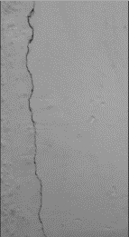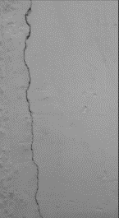

Final output image with the crack and aberrations after obtaining area of higher confidence using oriented non max suppression.

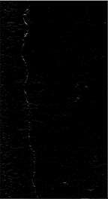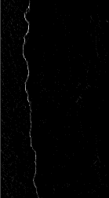 Input gray image

Gaussian blur

After vertical Sobel edge detection

After Horizontal Sobel edge detection

After Vertical Sobel edge detection

Gray image – Gaussian Blur

Gray image -Gaussian blur